**Python requirements setup and Program to get the tweets data from Twitter API**

Installing tweepy in python Package:

git clone git://github.com/tweepy/tweepy.git

cd tweepy

python setup.py install

Please navigate to the folder where your python is installed.

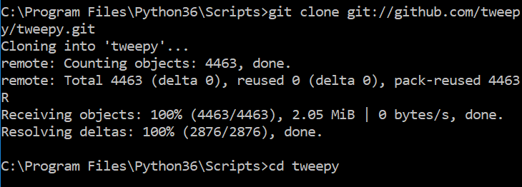

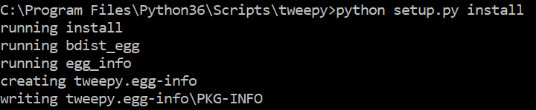

If tweepy is installed in different packge try to uninstall it by below command:

pip uninstall tweepy

To test pip and tweety packages are installed or not please use the below command in Command promt

Navigate to the Python \Scripts folder and run the below command

Pip freeze

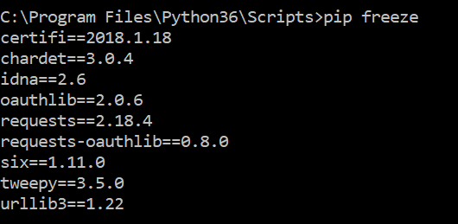

To run program you need two packages

Pip 🡪 to install tweepy

Tweepy🡪to get data from twitter

After you verify the tweepy and pip. Try to create new python program in pycharm.

If **import tweepy** is giving error go to project settings and project interpreter.

Create a new virtual environment and press ok.

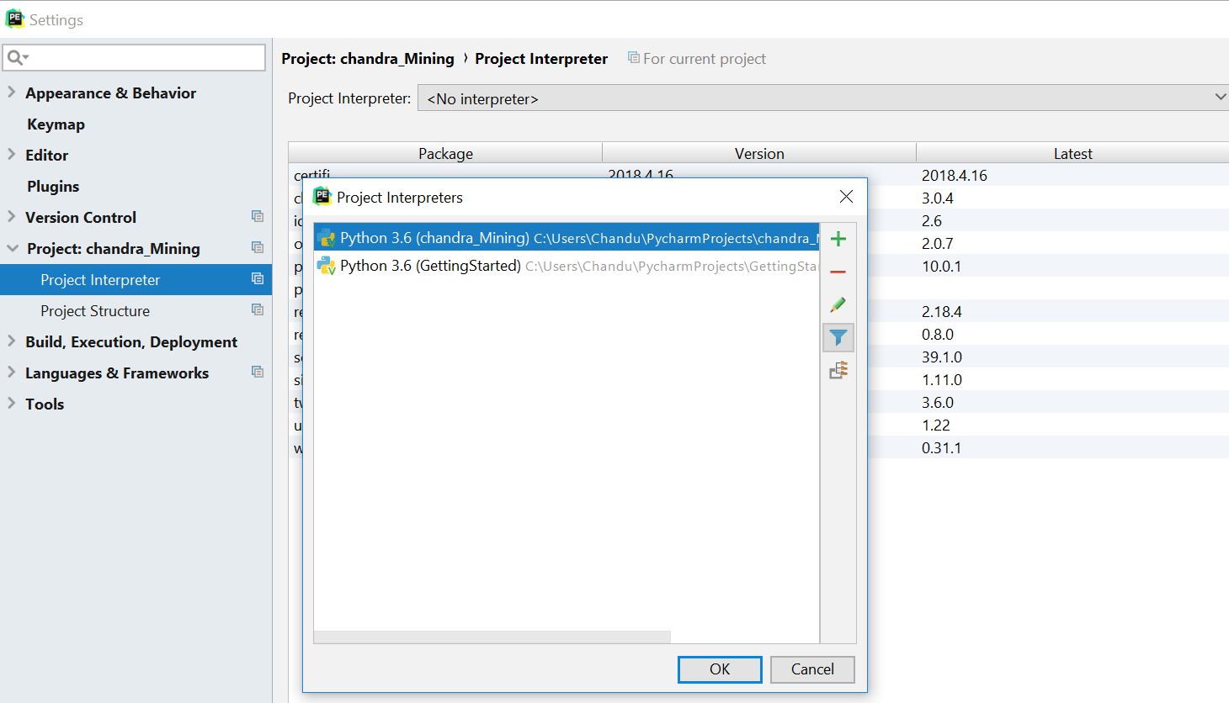

Select inherit global site-packages while you creating an virtual environment.

Once you press ok. You will see all the packages available in your virtual environment.